MID-STATE DIFFERENCES IN
JOB OPPORTUNITIES FOR
MARYLAND WELFARE RECIPIENTS

Anne Arundel County, Baltimore City, Baltimore County,
Montgomery County and Prince George’s County

Submitted to:

Office of Programs
Family Investment Administration
Maryland Department of Human Resources
311 West Saratoga Street
Baltimore, MD 21201-3521

Submitted by:

Jane Staveley
Senior Research Associate
The Jacob France Institute
University of Baltimore
1420 North Charles Street, BC-368
Baltimore, MD 21201-5779
jstaveley@ubalt.edu
410-837-6552

June 2008

The coauthors of this report are Jane Staveley and David Stevens. They accept full responsibility for the accuracy of the data presented, statements made and conclusions reached. This is the third in a series of Institute reports that deliver new decision-making tools to DHR/FIA and local DSS staffs. John Janak and Stacey Lee contributed to the updating of TCA recipient and Census Bureau Local Employment Dynamics data included here.

TABLE OF CONTENTS

PAGE

1.0 INTRODUCTION . . . . . . . . . . . . . . . . . . . . . . . . . . . . . . . . . . . . . 1

2.0 DATA SOURCES AND DEFINITIONS . . . . . . . . . . . . . . . . . . . . 2
2.1 Welfare recipient data source . . . . . . . . . . . . . . . . . . . . . 2
2.2 Work-eligible welfare recipients . . . . . . . . . . . . . . . . . . . . 2
2.3 Local area coverage . . . . . . . . . . . . . . . . . . . . . . . . . . . . . 2
2.4 The local business hires data source. . . . . . . . . . . . . . . . 3
2.5 The stable new hires indicator . . . . . . . . . . . . . . . . . . . . . 4
2.6 The unachievable ideal and the available substitute . . . . 4
2.7 A guide to the calculations that follow in section 3 . . . . . 5

3.0 FINDINGS . . . . . . . . . . . . . . . . . . . . . . . . . . . . . . . . . . . . . . . . . 6

3.1 Top 10 industry subsectors ranked based on local stable
new hires . . . . . . . . . . . . . . . . . . . . . . . . . . . . . . . . . . . . . 6
3.2 Local stable new hires for top 10 NAICS industry subsectors . 9
3.3 Ratios of work-eligible welfare recipients to:
(1) summed local stable new hires in ranked top 10
industry subsectors; and (2) all industry subsectors . . . . 11

4.0 CONCLUSIONS . . . . . . . . . . . . . . . . . . . . . . . . . . . . . . . . . . . . . 14

LIST OF TABLES

TABLE 1(a) Top 10 Industry (NAICS) Subsectors Based on Average
Quarterly Local Stable New Hires of Women Ages 19-24
July 2006-June 2007 . . . . . . . . . . . . . . . . . . . . . . . . . . . . . . . . . . . . . . . 8

TABLE 1(b) Top 10 Industry (NAICS) Subsectors Based on Average
Quarterly Local Stable New Hires of Women Ages 25-34
July 2006-June 2007 . . . . . . . . . . . . . . . . . . . . . . . . . . . . . . . . . . . . . . . 8

TABLE 2(a) Average Number of Quarterly Local Stable New Hires
of Women Ages 19-24 in Top 10 Industry (NAICS) Subsectors
ranked by Number of Local Stable New Hires July 2006-June 2007 . . . . 10

TABLE 2(b) Average Number of Quarterly Local Stable New Hires
of Women Ages 25-34 in Top 10 Industry (NAICS) Subsectors
ranked by Number of Local Stable New Hires July 2006-June 2007 . . . . . 10

TABLE 3(a) Ratios of Work-Eligible TCA Women Ages 19-24
To Sum of Top 10 Local Industry Subsector Stable New Hires and to
All Local Industry Subsector Stable New Hires Both Age Group-Specific
and Average July 2006-June 2007 . . . . . . . . . . . . . . . . . . . . . . . . . . . . . . . 13

TABLE 3(b) Ratios of Work-Eligible TCA Women Ages 25-34
To Sum of Top 10 Local Industry Subsector Stable New Hires and to
All Local Industry Subsector Stable New Hires Both Age Group-Specific
and Average July 2006-June 2007 . . . . . . . . . . . . . . . . . . . . . . . . . . . . . . . . 13
ABSTRACT

The February 2008 Reauthorization of the Temporary Assistance for Needy Families (TANF) Program; Final Rule, which is effective October 1, 2008, sets forth effort to work expectations for welfare recipients defined by the Final Rule as work-eligible. No recognition is given to local differences in labor market conditions that impact whether a recipient’s effort to find a job is rewarded with success.

In this report we answer three questions about differences in mid-Maryland labor market conditions that should be considered by Maryland Department of Human Resources headquarters staff and local Department of Social Services front-line staffs charged with carrying out the Final Rule effort to work mandate:

- What is the top 10 ranking of local industries based on recent hires of women in defined age groups?

2. How many hires of women in the defined age groups were there from July 2006 to June 2007 in each of these ranked industries?

3. What are the ratios of work-eligible welfare recipients to the sum of local hires of women in the top 10 ranked industries; and to the sum of all local hires of women?

Tables in this report document two distinct types of local labor market difference relevant for local office staff targeting of job opportunities for welfare recipients:

- Local labor market opportunity differences between age groups within a local area; and

- Local labor market opportunity differences among local areas within age group.

We highlight two important findings:

- The Baltimore City age-specific ratios of defined welfare recipient subgroups to gender- and age-specific business hires are much higher than the ratio values for Prince George’s County, Baltimore County, Anne Arundel County and Montgomery County. This indicates that there are fewer job opportunities in Baltimore City than in each of the other four counties for female work-eligible welfare recipients in a defined age group.

- The difference between Baltimore City and Montgomery County job opportunities is extreme, while Prince George’s County, Baltimore County and Anne Arundel County cluster together between the other two.

- The ratio of work-eligible welfare recipients to local business hires for Baltimore City female work-eligible recipients ages 19-24 is higher than the same ratio estimate for Baltimore City female work-eligible recipients ages 25-34. We interpret this to mean that there are fewer job opportunities in Baltimore City for the younger female work-eligible welfare recipients.

We have used the most current available information about mid-Maryland job opportunities for women ages 19-34 to estimate local differences in how many hires can be thought of as ‘relevant’ for local office staff assistance to carry out the mandate to move more families to self-sufficiency and independence. Our opportunity estimates are based on July 2006-June 2007 business hires information by mid-Maryland county, gender and age group.

We encourage Maryland Department of Human Resources headquarters staff and local Department of Social Services front-line staffs to use Table 3(a) and Table 3(b) column 5 ratios, found on page 13, as a starting point for thought and conversation about how local differences in job opportunities should be translated into actions consistent with the mandate to move more families to self-sufficiency and independence. We remain available to participate in this conversation and hasten progress toward the shared goal of TCA recipient self-sufficiency and independence.

1.0 INTRODUCTION

This report is the third in a series of Jacob France Institute (JFI) technical assistance reports that document local differences in the ratio of welfare recipients to business hires. These updated estimates can improve local Department of Social Services staff understanding of job-finding prospects for work-eligible welfare recipients.

Differences in local labor market opportunities for work-eligible welfare recipients are important because the February 2008 Reauthorization of the Temporary Assistance for Needy Families (TANF) Program; Final Rule defines personal responsibility and serious effort to work expectations for work-eligible welfare recipients. No recognition is given to local differences in labor market conditions that impact whether and how a commitment to personal responsibility and serious effort to work is rewarded with success.

Section 2 describes the data sources used to calculate ratios of welfare recipients to local business hires and defines three basic terms used to present the local ratio estimates—work-eligible welfare recipients, age groups and industries ranked by local private business hires of women in these age groups. The ratio estimates appear in Section 3. Conclusions follow in Section 4.

2.0 DATA SOURCES AND DEFINITIONS

2.1 Welfare recipient data source

An Interagency Agreement between the Maryland Department of Human Resources Family Investment Administration and JFI supports JFI maintenance and updating of monthly Client Automated Resource and Eligibility System (CARES) record extracts. For this report we used data fields from the July 2006-June 2007 monthly CARES records.

2.2 Work-eligible welfare recipients

Our definition of work-eligible welfare recipients is female household heads ages 19-34 with related children that received cash assistance in any month or combination of months between July 2006 and June 2007.

Coverage of work-eligible female head-of-household welfare recipients ages 19-34 with related children is split into two age groups—ages 19-24 and ages 25-34—that align with defined age groups in the available local business hiring data described in subsection 2.4 below.

2.3 Local area coverage

The 2006 report in this series included only Baltimore City and Baltimore County. The 2007 report offered statewide coverage. This new report contains welfare recipient to local business hires ratio estimates for five local Department of Social Services jurisdictions—Anne Arundel County, Baltimore City, Baltimore County, Montgomery County, and Prince George’s County. These five counties account for a high percentage of the Maryland work-eligible welfare recipient caseload.

2.4 The local business hires data source

The Census Bureau began a new Longitudinal Employer-Household Dynamics (LEHD) Program in 1998. A Local Employment Dynamics (LED) initiative within the LEHD Program is a state-federal partnership that collects, organizes and makes accessible indicators of local labor market activity and conditions. A feature of this initiative, Industry Focus, is particularly useful to study differences and changes in local employment opportunities for welfare recipients.

April-June 2007 Industry Focus information was the most recent available when we selected indicator values to calculate local labor market differences for this report. Updates and modifications of the summary tables that appear here can be delivered with little delay as new quarterly releases of data are posted.

Eight indicators of labor market conditions are available at Industry Focus:
total employment; growth in employment; growth in hiring; number of new hires; firm job change; average monthly earnings for all workers; growth in average monthly earnings for all workers; and average monthly earnings for new hires.

The Industry Focus online feature allows selection from the following options:

- Predefined age group (8 groups);
- Gender;
- Industry—North American Industry Classification System (NAICS) sector (two-digit code) or subsector (three-digit code);
- Geography (State, county, Workforce Investment Act local area designation, or defined metro area).

We selected number of new hires of women ages 19-24 and ages 25-34, by NAICS subsector, reported separately for Anne Arundel County, Baltimore City, Baltimore County, Montgomery County, and Prince George’s County.

2.5 The stable new hires indicator

The Census Bureau LEHD Program software detects employer-employee pairings that are sustained for three consecutive quarters—t, t+1 and t+2. Employment in the middle quarter, t+1, of a three-quarter series is defined as a stable employment observation. If the same employer-employee pairing is not found for the t-1 quarter—the quarter before quarter t—this is defined as a hire event in quarter t. The label new hire is added to indicate when an employee counted as a hire in quarter t had not been reported as an employee by the same employer in any of the three previous quarters—t-2, t-3 and t-4.

We summarize the previous paragraph—a stable new hire occurs when an employee begins work in reference quarter t and then is reported by the same employer as still being employed in both quarter t+1 and quarter t+2. Our intent here is to focus attention on mutually satisfied employers and employees—those who have maintained their paired status for more than three months. Employee churning—frequent turnover after little time on the job—is not included in the ratio estimates presented in this report.

2.6 The unachievable ideal and the available substitute

Ideally, for a defined date we would like to be able to compare an exact count of local work-eligible welfare recipients with an exact count of local job openings that satisfy practical access and candidate qualification criteria. Such job opening and access information is not available.

By definition a job opening is unfilled so we do not know what combination of candidate attributes, worksite location and job descriptors may hypothetically result in a successful hire—a combination that satisfies both the employer and the job applicant. There is no consensus about what access means, exemplified by ongoing commuter responses to rising gas prices. Individuals respond to distance, time, out-of-pocket costs, and changes in these attributes of access, in unpredictable ways.

In this report we substitute Industry Focus stable new hires information organized by county, industry subsector, age group and gender for the unmeasured exact count of local job openings that satisfy practical access and candidate qualification criteria.

  - A guide to the calculations that follow in section 3

Section 3 contains six tables:

- Table 1a—Ranking of top 10 industries based on average quarterly local stable new hires, July 2006-June 2007, women ages 19-24 for each of five counties.

- Table 1b—Ranking of top 10 industries based on average quarterly local stable new hires, July 2006-June 2007, women ages 25-34 for each of five counties.

- Table 2a—Average quarterly number of local stable new hires, July 2006-June 2007, in top 10 ranked industries, women ages 19-24 for each of five counties.

- Table 2b—Average quarterly number of local stable new hires, July 2006-June 2007, in top 10 ranked industries, women ages 25-34 for each of five counties.

- Table 3a—Ratios of work-eligible TCA women ages 19-24 to sum of top 10 local industry subsector stable new hires and to all local industry subsector stable new hires. Both ratios are age group-specific and represent averages over July 2006-June 2007. Ratio numerator and denominator definitions and time alignment assumptions are explained in Section 3.3.

- Table 3b— Ratios of work-eligible TCA women ages 25-34 to: (1) sum of top 10 local industry subsector stable new hires; and (2) all local industry subsector stable new hires. Both ratios are age group-specific and represent averages over July 2006-June 2007. Again, the ratio numerator and denominator definitions and time alignment assumptions are explained in Section 3.3.

Each of the three numbered (a) and (b) series tables appears on a single page for ease of comparison between the two age groups and among the five counties. The progression from Table 1 through Table 2 to Table 3 answers three questions in a logical sequence.

- Table 1(a) and Table 1(b) answer the question: What is the top 10 ranking of local industry subsectors based on number of stable new hires of women in a defined age group?

- Table 2(a) and Table 2(b) answer the question: How many local stable new hires of women in a defined age group were there in an average quarter from July 2006 to June 2007 in each of these ranked industry subsectors?

- Table 3(a) and Table 3(b) answer the question: What are the ratios of work-eligible welfare recipients to: (1) the sum of local stable new hires of women in the top 10 ranked industry subsectors; and (2) the sum of all local industry subsector stable new hires?

3.0 FINDINGS

3.1 Top 10 industry subsectors ranked based on local stable new hires

Table 1(a) in the upper half of page 8 shows industry subsectors (three-digit NAICS codes and titles) ranked 1 through 10 based on county average quarterly stable new hires of women ages 19-24 from July 2006 through June 2007. This table and Table 1(b) in the lower half of the same page for women ages 25-34 include a combined 17 NAICS industry subsector codes.

The combined total of 17 three-digit North American Industry Classification System (NAICS) industry subsector codes that appear in Table 1(a) and Table 1(b) are:

238—specialty trade contractors
445—food and beverage stores
446—health and personal care stores
448—clothing and clothing accessories stores
452—general merchandise stores
522—credit intermediation and related activities
524—insurance carriers and related activities
531—real estate
541—professional, scientific, and technical services
561—administrative and support services
611—educational services
621—ambulatory health care services
622—hospitals
623—nursing and residential care facilities
624—social assistance
722—food services and drinking places
812—personal and laundry services
The 17 pairings of NAICS industry subsector codes indicate that the age-specific county rankings based on local stable new hires are not identical. If the rankings were uniform only 10 NAICS codes would appear in the combination of Table 1(a) and Table 1(b).

Look, for example, at the NAICS industry subsector code ranked number one—the first column reading from left to right. In Table 1(a) for women ages 19-24 NAICS industry subsector code 722 (food services and drinking places) is ranked first in all five counties; but in Table 1(b) for women ages 25-34 the top ranking is distributed across four three-digit NAICS industry subsector codes, only one of which is code 722.

The Table 1(a) and Table 1(b) rankings should be heeded by local DSS staffs charged with carrying out the February 2008 Final Rule personal responsibility and serious effort to work expectations. A work-eligible TCA recipient’s age and location should be considered in targeting local office assistance.
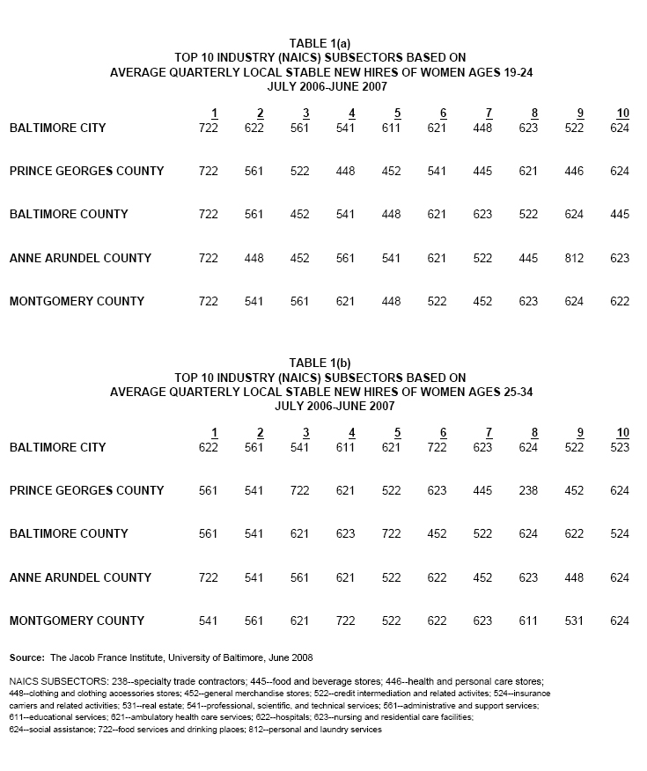
3.2 Local stable new hires for top 10 NAICS industry subsectors

The format of Table 2(a) and Table 2(b) is the same as the format for Table 1(a) and Table 1(b) on page 8, except that each row-column cell number in the new tables on page 10 is a local average quarterly stable new hires estimate for the industry subsector in the same row-column cell of the previous table. For example, the Table 2(a) first row and first column cell number is 373. This is the quarterly average number of NAICS code 722 (food services and drinking places) stable new hires of women ages 19-24 in Baltimore City from July 2006 through June 2007.

A five-county comparison of stable new hires profiles for the top 10 ranked industry subsectors within Table 2(a) or Table 2(b) shows interesting similarities and differences. Table 2(a) shows that the quarterly average number of stable new hires of women ages 19-24 is roughly the same in the top ranked food services and drinking places industry subsector in Baltimore City, Prince George’s County and Anne Arundel County. Montgomery County and Baltimore County show a higher number of stable new hires in this industry subsector.

A comparison between Table 2(a) and Table 2(b), looking at the last column reading from left to right, labeled sum, there are clear age-related differences in the average quarterly sum of top 10 ranked industry subsector stable new hires in Baltimore City, Prince George’s County and Montgomery County, but not in Baltimore County or Anne Arundel County.

Again, the message for local DSS staffs is that age and location matter in targeting promising industries for work-eligible TCA recipient action.

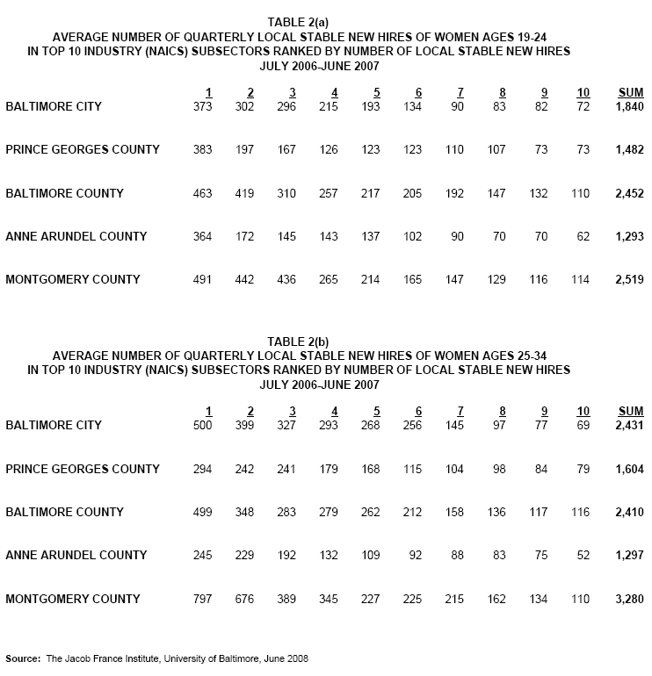
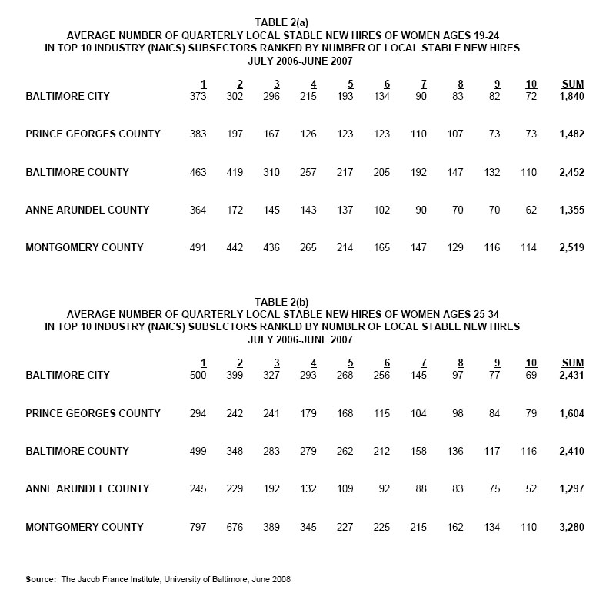

3.3 Ratios of work-eligible welfare recipients to: (1) summed local stable new hires in ranked top 10 industry subsectors; and (2) all industry subsectors

We have arrived at the point in this report where numbers from different sources can be brought together and transformed into clear indicators of local differences in job opportunities for female work-eligible welfare recipients. Table 3(a) and Table 3(b) on page 13 show two distinct types of difference relevant for DSS local office targeting of job opportunities for welfare recipients:

- Differences between age groups within a local area; and

- Differences among local areas within age group.

Look first at Table 3(a) row 1 column 5. The Top 10 hires ratio number 0.44 appears for Baltimore City female work-eligible welfare recipients ages 19-24. The following steps were used to calculate this ratio number:

- The ratio numerator calculation started with the row 1 column 1 number 3,270, which is the unduplicated count of Baltimore City female work-eligible welfare recipients ages 19-24, from July 2006 through June 2007. This count over 12 months is intended for alignment with quarterly Baltimore City business hires data to answer the question: How many relevant local hires is a work-eligible recipient ‘exposed’ to during her TCA benefit spell(s)?
- For this report we assume an average TCA benefit duration of six months between July 2006 and June 2007, so we divided the 3,270 year-long count of recipients by 2 to arrive at a six-month estimate of 1,635 work-eligible female welfare recipients ages 19-24 in Baltimore City—the derived number does not appear in Table 3(a). This number 1,635 is the numerator value used to calculate the Table 3(a) row 1 column 5 ratio result of 0.44.

- To calculate the denominator value of the Table 3(a) row 1 column 5 ratio our next step was to start with the Table 3(a) row 1 column 2 number 1,840, which is the sum of top 10 industry subsector average quarterly stable new hires from July 2006 through June 2007. This is a quarterly value, but we need a six-month denominator number that aligns with the numerator six-month derived estimate of 1,635 work-eligible female welfare recipients in Baltimore City. So we multiplied the average quarterly stable new hires number 1,840 by 2 to arrive at a six-month estimate of 3,680 top 10 industry subsector stable new hires of women ages 19-24 in Baltimore City.

- Our third and final step to arrive at the Table 3(a) row 1 column 5 ratio value of 0.44 was to divide the derived numerator number 1,635 by the derived denominator number 3,680—1,635/3,680=0.44.

As we stated on page 1 footnote 1, a ratio value > 1 indicates that there are more female work-eligible welfare recipients in a defined age group than local stable new hires in the defined industry subsectors for women in the same age group, given the cautions we describe on page 11, footnote 16. The Table 3(a) row 1 column 5 derived ratio value of 0.44 indicates that there were 2+ stable new hires of women ages 19-24 in Baltimore City for each woman in the defined pool of local work-eligible welfare recipients.

Each of the remaining ratio values shown in columns 5 and 6 of Table 3(a) and Table 3(b) were calculated following the same sequence of steps described above. The difference between columns 5 and 6 in both tables is the scope of industry subsector coverage—column 5 includes only the top 10 ranked industry subsector stable new hires, while column 6 includes all industry subsectors. Our ratio definitions mean that the derived ratio in column 6 of a row must be lower than the column 5 ratio value because the column 6 denominator value is larger, including all industry subsector stable new hires.

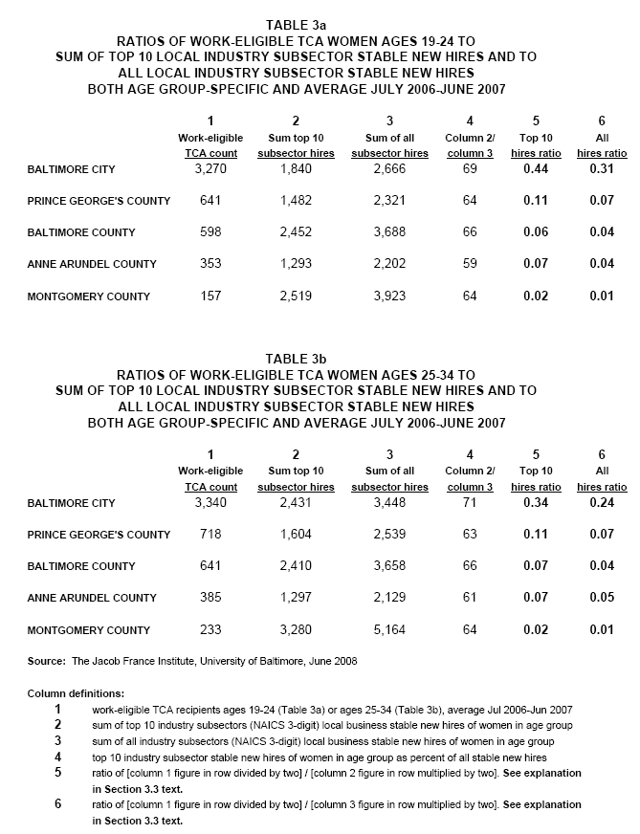
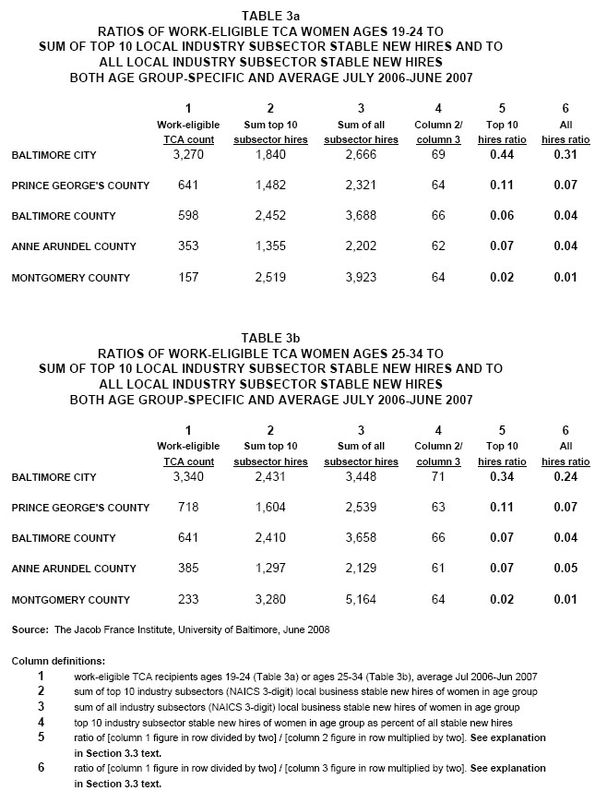
We highlight the following important differences selected from the bold font ratio values in columns 5 and 6 of Table 3(a) and Table 3(b) on page 13:

- Within each of the tables, the Baltimore City column 5 and column 6 ratios are much higher than any of the other four county ratio values. This indicates that there are fewer job opportunities in Baltimore City than in each of the other four counties for female work-eligible welfare recipients in a defined age group. The difference between Baltimore City and Montgomery County job opportunities is extreme, while Prince George’s County, Baltimore County and Anne Arundel County cluster together between the other two.

- The Table 3(a), row 1, columns 5 and 6, ratio estimates for Baltimore City female work-eligible TCA recipients ages 19-24 are higher than the same row-column ratio estimate in Table 3(b) for Baltimore City female work-eligible TCA recipients ages 25-34. We interpret this to mean that there are fewer job opportunities in Baltimore City for the younger female work-eligible welfare recipients.

- A row-specific comparison of column 5 and column 6 ratio values in either Table 3(a) or Table 3(b) indicates that expansion of denominator coverage from the top 10 ranked industry subsectors to all industry subsectors does not improve local DSS office staff understanding of differences in estimated job opportunities between the age groups and among the counties. DSS staff concentration on the top 10 ranked industry subsectors is recommended for client assistance purposes.

4.0 CONCLUSIONS

The effective date of the February 2008 Reauthorization of the Temporary Assistance for Needy Families (TANF) Program: Final Rule is October 1, 2008. The last sentence of the supplementary information introduction to the Final Rule is: Under this final rule States are accountable for moving more families to self-sufficiency and independence.
We have used the most current available information about mid-Maryland job opportunities for women ages 19-34 to estimate local differences in how many hires can be thought of as ‘relevant’ for local DSS staff assistance to carry out the mandate to move more families to self-sufficiency and independence. Our opportunity estimates are based on July 2006-June 2007 stable new hires information by mid-Maryland county, gender and age group.

We encourage Maryland Department of Human Resources headquarters staff and local Department of Social Services front-line staffs to use Table 3(a) and Table 3(b) column 5 ratios, found on page 13, as a starting point for thought and conversation about how local differences in job opportunities should be translated into actions consistent with the mandate to move more families to self-sufficiency and independence. We remain available to participate in this conversation and hasten progress toward the shared goal of TCA recipient self-sufficiency and independence.

The ratio of welfare—temporary cash assistance (TCA)—recipients (numerator) to hire transactions (denominator), as each term is defined in this report, is a convenient way to show local differences in hiring prospects—a ratio value > 1 means there are more welfare recipients than hires. A ratio value < 1 indicates that there are more hires than welfare recipients.
The previous two reports in this series are: David W. Stevens (2006), New Information to Promote Successful Job Search by Temporary Cash Assistance Recipients, Baltimore, MD: The Jacob France Institute, University of Baltimore, 18 pp. (available at http://www.ubalt.edu/jfi); and David W. Stevens (2007), Maryland Local Departments of Social Services Face Different Job Opportunity Challenges When Assisting Work-Eligible TCA Recipients to Find Employment, Baltimore, MD: The Jacob France Institute, University of Baltimore, 13 pp. (also available at http://www.ubalt.edu/jfi).
Federal Register, Volume 73, Number 24, February 5, 2008, pp. 6771-6828.
The CARES is one of at least five data systems maintained by the DHR Office of Technology for Human Services. Other DHR IT systems include the Child Support Enforcement System (CSES), the Electronic Benefits Transfer System (EBTS), the Office of Home Energy Programs (OHEP), and the Children’s Electronic Social Services Information Exchange (MD CHESSIE).
Age is defined at the time of first TCA benefit received during these 12 months.
Two parent households, disabled cases and domestic violence cases, as these are defined in a CARES data field labeled ‘stratum’, are excluded from this work-eligible subpopulation definition.
The 2006 report used a restricted access DVD data source that required many hours of JFI staff time to extract and work with defined local areas, so the ratio estimates were limited to these two contiguous DSS jurisdictions and a single ‘core’ labor market.
The 2007 report took advantage of the web-based availability of statewide hires estimates by industry, gender and age group that could easily be rank ordered for each of the 12 local Workforce Investment Board jurisdictions in Maryland.
This subsection repeats relevant data source descriptive text and data field definitions from the 2006 and 2007 reports in this series.
The Industry Focus data are available at http://lehd.did.census.gov; under Quick Links click on Industry Focus and select from available drill-down options.
Available online at http://www.census.gov/epcd/naics07/naics07.xls. In addition to the two-digit sectors and three-digit subsectors the NAICS taxonomy includes four-digit industry groups, five-digit industries and six-digit United States detail industries. The Census Bureau LEHD Program Industry Focus online site contains only two-digit and three-digit NAICS coded data.
The official Industry Focus indicator label is ‘new hires’, but caution is urged—the actual value that is reported at Industry Focus is number of stable new hires, not all new hires.
This label of stable employment cannot be assigned to the first or third quarters in the three-quarter sequence without additional information about the existence of the employer-employee pairing in the quarter preceding the first quarter or the quarter following the third quarter.
A person could begin work on the last day of quarter t and be reported as employed by the hiring employer for that quarter, then continue through all of quarter t+1 and be reported as employed for a second consecutive quarter, and finally work one day in quarter t+2 and leave for another job or activity but be reported as employed for the third consecutive quarter.
NAICS subsector (three-digit) designations.
Our phrase “job opportunities for female work-eligible welfare recipients” requires elaboration. The hires numbers we present in this report are defined by location (county), gender (female), age group (ages 19-24 or ages 25-34) and industry subsector (NAICS three-digit). Our decision to compare these hires figures to a count of female work-eligible welfare recipients in the same age ranges implicitly assumes that current and future job opportunities for these work-eligible designees are defined by and only by the local business affiliations of July 2006-June 2007 new hires of women in the same age spans. Unobserved forces work in opposite directions to influence the relevance of our hires estimates for local DSS staff actions. Our hires figures understate local job opportunities for female work-eligible welfare recipients if these welfare recipients can successfully compete for local jobs not previously held by women in the same age range. But our hires figures overstate local job opportunities for female work-eligible welfare recipients if some of the local jobs previously held by women in the same age range are not realistic opportunities because of unobserved differences—such as lower educational attainment, substance abuse history, criminal conviction, and less favorable previous employment profile. There is no occupational descriptor in the Industry Focus data source, so we do not know the occupational distribution of 2006-2007 hires of women in mid-Maryland. Another source of overstatement is that our ratio calculation assumes that the female work-eligible welfare recipients compete for job offers only among themselves, not with the unobserved pool of other women and men that compete for the same jobs. Other considerations include: (1) our hires figures in this report cover only private business hires, but we know that a substantial number of local government jobs are held by or potentially available to women; and (2) there is some measurement error of unknown size in the assignment of business hire transactions to a defined location. We do not think that these warnings should cause local DSS staffs to ignore the targeting implications of our Table 3(a) and Table 3(b) findings.
The 2007 report in this series—David W. Stevens (2007), Maryland Local Departments of Social Services Face Different Job Opportunity Challenges When Assisting Work-Eligible TCA Recipients to Find Employment, Baltimore, MD: The Jacob France Institute, University of Baltimore, 13 pp. (available at http://www.ubalt.edu.jfi) –page 10, Table 3, column 5, shows a much higher ratio value for each of the five counties than appears in the current 2008 report, page 13, Table 3(a) and Table 3(b), column 6. For example, the 2007 report ratio of TCA recipients to all hires is 1.9, while the current report, Table 3(a), column 6 ratio value is 0.31, and the Table 3(b), column 6 ratio value is 0.24. This should not be interpreted to mean that job opportunities for female welfare recipients in Baltimore City have improved dramatically in the past year. There are many critical definition and calculation differences in the 2007 and 2008 reports. The approach adopted in the current report offers a better estimate of local job opportunities for work-eligible welfare recipients in mid-Maryland.

